OutreachModule test version server setup instructions

Version 1.0 December 3, 2014

Version 2.0 January 6, 2015

By Simon Bromberg [simon.bromberg@mail.utoronto.ca](mailto:simon.bromberg@mail.utoronto.ca)

You will need IIS (Internet Information Services). Currently also will need Visual Studio Express 2013. There are also a few key setup steps.

**Install IIS:**

Start menu > Programs and Features

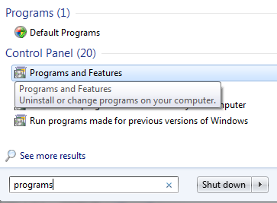

On sidebar click “Turn Windows Features on or off” (takes a few moments to load)

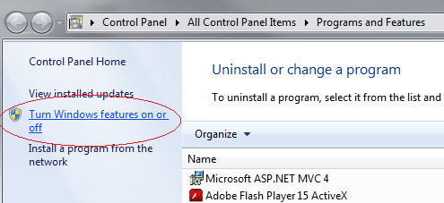

Click on box next to “Internet Information Services” Doesn’t become a checkbox, that’s ok, only need the default stuff. Click OK and wait while it sets up IIS.

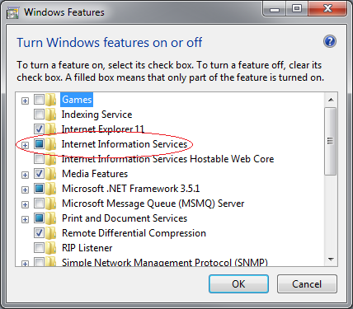

You can check it worked by going to “localhost” in your web browser. Should see this image:



**Now to set up IIS for our application:**

From the Start menu type in “IIS” and open Internet Information Services (IIS) Manager

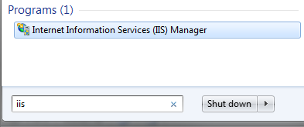

Click the arrow next to root object in the Connections list on the left.

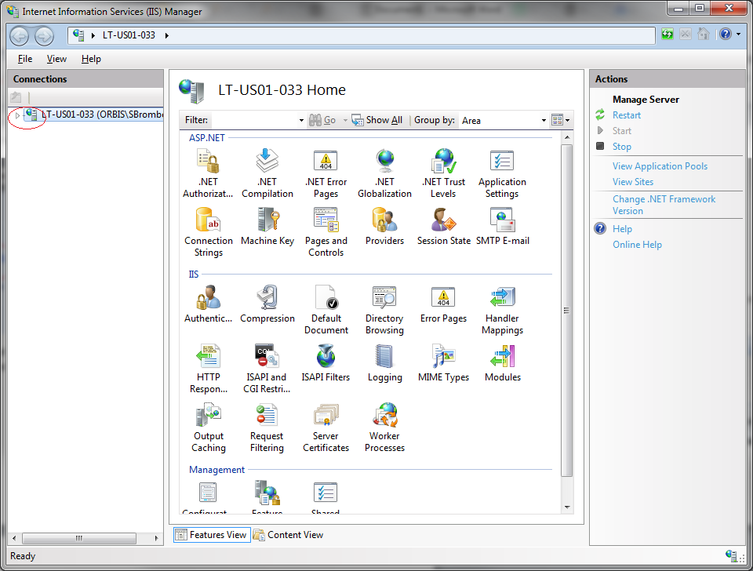

That will reveal “Application Pools” and “Sites”. Click “Application Pools”

In the middle panel, double-click “DefaultAppPool” and change the .NET Framework version to v4.0.30319 from v2.0.50727

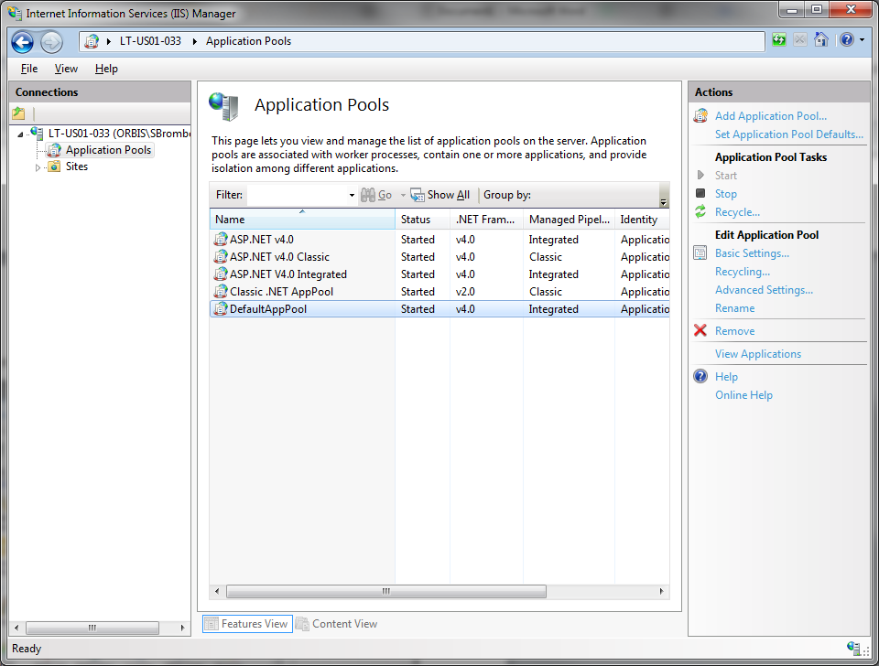

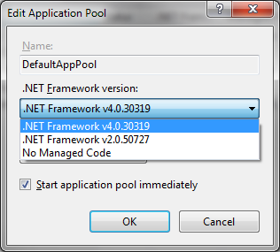

**Now to set up ASP.net on IIS:**

Open the Windows command terminal from the start menu **as an administrator**

Type cmd, right click, “Run as administrator”, click yes in the popup that comes up

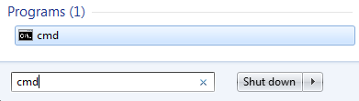

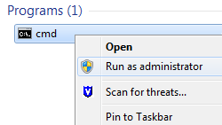

Inside the command utility, type:

cd \Windows\Microsoft.NET\Framework\v4.0.30319

and then press Enter to change to the directory containing the version of asp.net we want. Note the utility doesn’t support copy/paste but you can just type the first few letters of each folder and then press tab to autocomplete the name.

On the new line it should show the current directory has been changed, and now type:

aspnet_regiis -iru

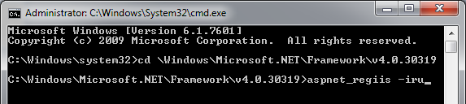

Wait a moment while it installs. Then you can close the window.

**Visual Studio:**

Go to <http://www.visualstudio.com/en-us/products/visual-studio-express-vs.aspx>

Click “Download”

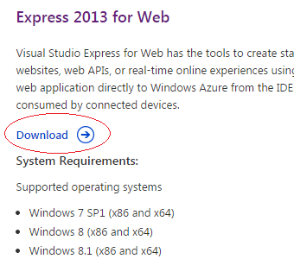

On the next page click “Install Now”

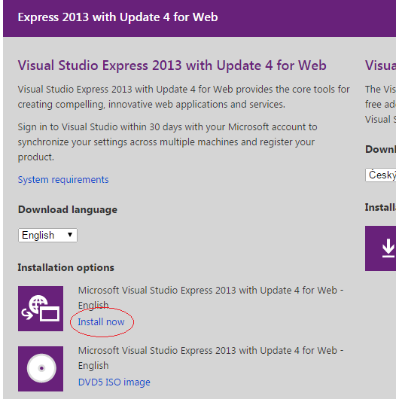

It will ask you to sign in to a Microsoft account. If you don’t have one, you can create one for free by clicking “Sign up now”

Once signed in click Express 2013 for Web on the left

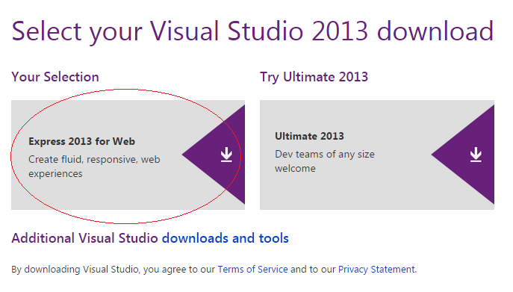

Installer will download. Open it when it’s finished. Click Run.

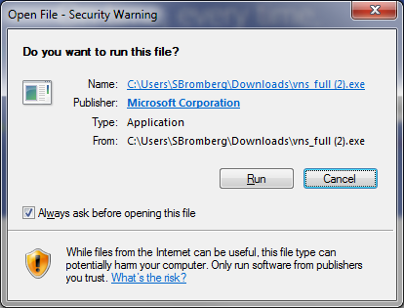

Click Install. Installation will probably take around 10 minutes. When it is done click LAUNCH.

You’ll need to re-open Visual Studio as an administrator, so close it, find it in the start menu, right-click, Run as administrator, click Yes in the popup.

Once inside Visual Studio Express 2013, click File > Open Project

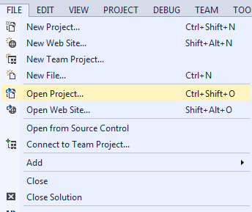

Navigate to the folder containing the OutreachModule Visual Studio project and click open.

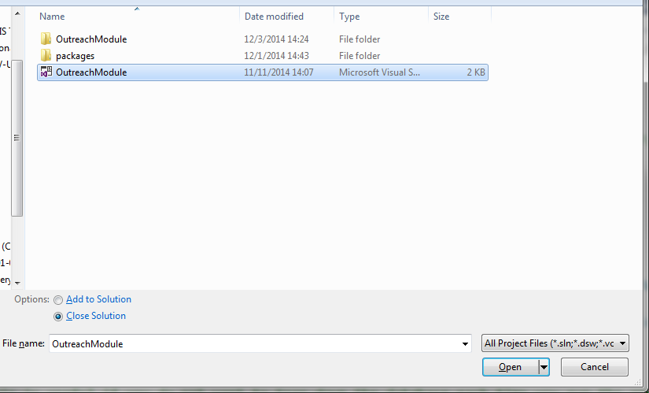

***ATTENTION:***

**EDIT Jan 6 2015:** Didn’t get publishingto workproperly, so just skip to END to use IIS Express instead of IIS publishing for now.

Right click on the project in the solution explorer on the right hand side and click “Publish”

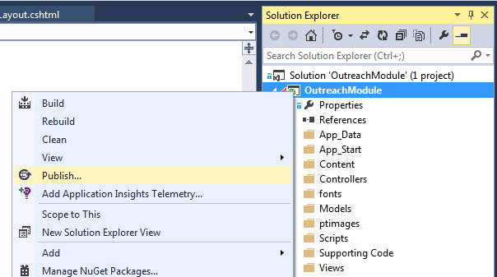

In the Publish Web window that comes up, click “Publish”

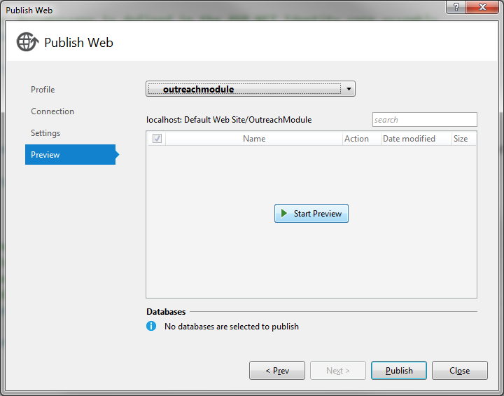

Let it build and deploy the project.

To get the server connection working navigate (using Windows Explorer) to C:\Windows\System32\inetsrv\config and open applicationHost.config in Notepad or whatever text editor you use (right click > Open With).

Find where it says

<applicationPoolDefaults>

<processModel identityType="ApplicationPoolIdentity" loadUserProfile="true" setProfileEnvironment="false" />

</applicationPoolDefaults>

Change “ApplicationPoolIdentity” to “NetworkService” and “false” next to setProfileEnvironment to “true”. Then save and close the file.

**In order to save and delete patient images:**

Navigate to C:\inetpub\wwwroot\OutreachModule

Right click on ptimages, click properties, click Security tab, click Edit next to “To Change permissions click Edit”, scroll down to “DefaultAppPool” and click the Full Control box.

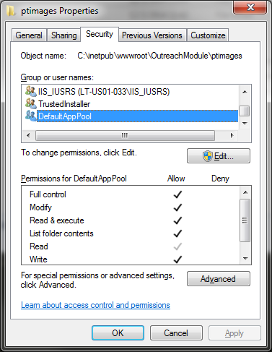

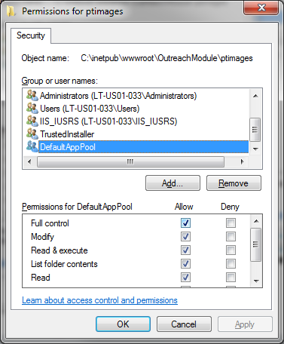

DefaultAppPool might not show up right away. Usually shows up after using the application. To add it manually follow the instructions here: <http://devonenote.com/2010/09/grant-permission-to-defaultapppool-identity/> (basically click Add, click Locations, click current computer which was LT-US01-033 in my case then press OK, then type IIS AppPool\DefaultAppPool in the box under “Enter the object names to select”, and click Check Names, then OK).

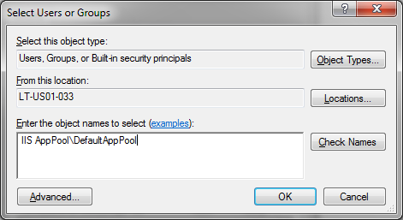

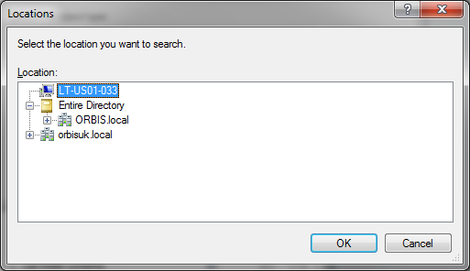

Go to localhost/OutreachModule to access the app. Login to make sure the database is working. Other devices on the same local network should be able to access the module via the server’s IP address

i.e. in browser address bar on other computer or mobile device on same network type:

*IP_ADDRESS*/OutreachModule

Where IP_ADDRESS is the IP address of the server computer. This can be found by opening the command utility (Start menu > cmd) and typing ipconfig. The IP address is next to IPv4 Address (may need to scroll up). The IP address will change depending on the router the server is connected to, so eventually it would be a good idea to use a static IP address and/or a custom host name so users don’t have to navigate to an IP address.

END

** Jan 6 2015 Edit, Skip publishing

Make sure Visual Studio is open as an administrator. Open the project. Then click the menu DEBUG > Start Debugging, or click the green play button in the toolbar. This will open a browser window with the URL localhost:[somenumbers]/outreachmodule (if anything after that it will probably load an error, so delete anything past outreachmodule. Should also work if outreachmodule is not there)

To get it working on other devices over the local network navigate to Documents > IISExpress > config > applicationhost (open this file with a text editor, don’t double click to open, right click and use open with and select Notepad or Wordpad or some other program – I like Sublime Text, available online)

In applicationhost find the following inside the <sites> tag: (things in square brackets are replacements made by me because they will be different on your computer).

<site name="OutreachModule" id="SOME NUMBERS">

<application path="/" applicationPool="Clr4IntegratedAppPool">

<virtualDirectory path="/" physicalPath="[PATH]" />

</application>

<application path="/OutreachModule" applicationPool="Clr4IntegratedAppPool">

<virtualDirectory path="/" physicalPath="[PATH]" />

</application>

**<bindings>**

**<binding protocol="http" bindingInformation="*:[numbers]:localhost" />**

**</bindings>**

</site>

Inside the <bindings> tag, add this (get IP from start menu > cmd > ipconfig)

<binding protocol="http" bindingInformation=":8080:[YOUR IP ADDRESS]" />

Will look something like this but with your IP address

<bindings>

<binding protocol="http" bindingInformation="*:[numbers]:localhost" />

**<binding protocol="http" bindingInformation=":8080:172.18.240.104" />**

</bindings>

Save the file, close it, re-run the project from Visual Studio. On other devices navigate to [IP ADDRESS]:8080, e.g. 172.18.240.104:8080 in a browser window

IF you have any problems or questions contact [simon.bromberg@mail.utoronto.ca](mailto:simon.bromberg@mail.utoronto.ca)